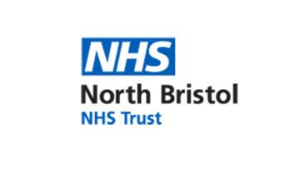
Registration form

Whole Body MRI Study Day- Tuesday 19th November 2019
Southmead Hospital, Bristol

Name including title:

Work address:

Telephone:

E-mail address:

Closing date for registration: 1st November 2019

Please send registration form to: gail.bailey@nbt.nhs.uk

Please note that registration is essential to attend the day and may close before 1st November once 35 candidates have registered
(first-come first-served basis).

